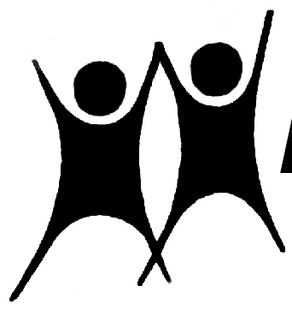

NAPE

Autumn 2020

News, Events and Contacts
NAPE National Office
Moulton College,
Moulton, Northampton.
NN3 7RR.

NEWS
Telephone: 01604 647646
Email: nationaloffice@nape.org.uk
Website: https://nape.org.uk/

Officers: Chair: Mike Aylen: MikeAylen@aol.com
Vice Chair: Mark Taylor: taylormc@mac.com
General Secretary: Robert Young: rmyoung1942@yahoo.co.uk
Treasurer: Angelo Pinto: angpinto@gmail.com
Information Officer: Peter Cansell: petercansell@gmail.com
Podcast: https://www.educationonfire.com/national-association-for-primary-education

Welcome to this Autumn edition of NAPE News. In these challenging and uncertain times I hope you have had a successful first half-term of the new academic year.
Media work
I was delighted to be asked back for a longer contribution to a programme on BBC Radio Kent at the beginning of July, we talked, among other things, about the protracted absence from school for many children and the impact this would have on Eleven plus exams in the area. I ensured that NAPE's views on selective education were fully aired.
We have continued to facilitate the Primary Umbrella Group (PUG), with a very informative online meeting attended by members from 20 different education associations on 21st September. We were joined by three headteachers
Rachel Ford, Head of Bannockburn Primary School, Royal Borough of Greenwich
Naheeda Maharasingam, Head of Rathfern Primary School, Lewisham LA
and Steve Bladon, Head of Horncastle Community Primary School, Lincolnshire,
to explore some of the educational issues raised by the pandemic and to look ahead at ways forward
On the same day I also joined an All Party Parliamentary Group for the teaching profession (APPG) online session.
Updates from the Chartered College, the Education Select Committee and a Special Interest Group meeting on Wellbeing
We heard from UCL regarding the Impact of Covid-19 on ITT, both for those qualifying in summer 2020 and those beginning training in Autumn 2021 and there was an NFER report on the impact of Covid on teacher training applications and a series of recommendations It was agreed to create another Special interest Group to look at assessment.
The National Executive met online on the 1st July
Our AGM finally took place on 12 September, as an online meeting
followed by a National council meeting
minutes of those meeting and all other meetings are available to members.
We continue to be part of the More Than a Score coalition, and I took part in a meeting online on 14th October with grave concerns being raised about phonics against the evidence for a wider approach shown in the research by Margaret Clark and her team.
Accessible on our website and from here:
https://www.newman.ac.uk/knowledge-base/the-phonics-screening-check-2012-2017
Our Podcast is growing considerably in its global reach and continues to attract high quality interviewees, it can be accessed through the address above or here: https://www.educationonfire.com/national-association-for-primary-education/
We are also invited to appear in other podcasts and I'm delighted to let you know that National Executive member Wendy Scott was interviewed recently by Dr Helen Edwards for Tapestry and is now live here:
https://fsf-podcasts.simplecast.com/episodes/transforming-lives-through-early-years-teaching-and-learning
They discuss Froebel and how his philosophy has influenced Wendy’s work in early education, building relationships with families, starting with the child, and how the early years can transform lives.
I hope that you have visited our revamped website https://nape.org.uk/ and that the easier navigation and added features are welcome.
We are getting close to half-term and I hope that you will have the opportunity to take some time to refresh yourself and your family with a break of some kind, perhaps by doing something different even if you can't get away anywhere.
And finally with the prospect of further lock downs in many parts of the UK and blended learning a central part of any Ofsted “non inspections” I wonder if this cartoon from the Philadelphia Inquirer rings any bells?

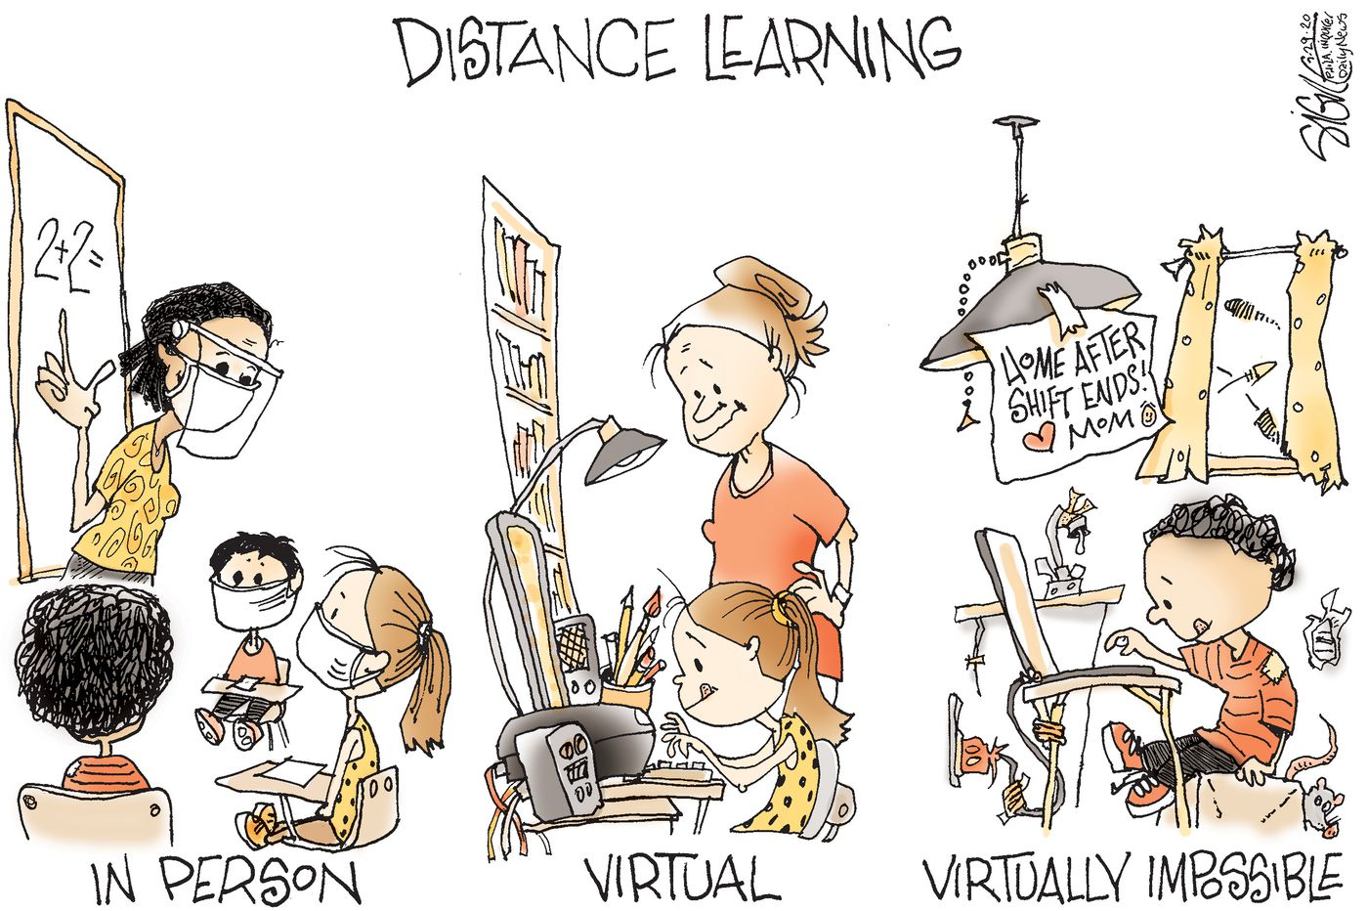

Have a good Half-term!

