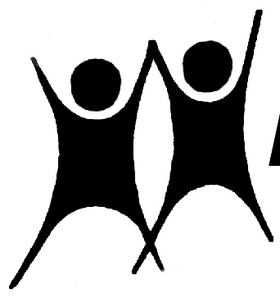

NAPE

Summer 2022

News, Events and Contacts
NAPE National Office
Moulton College,
Moulton, Northampton.
NN3 7RR.

NEWS
Telephone: 01604 647646
Email: nationaloffice@nape.org.uk
Website: https://nape.org.uk/

Officers: Chair: Mike Aylen: MikeAylen@aol.com
Vice Chair: Mark Taylor: taylormc@mac.com
General Secretary: Robert Young: rmyoung1942@yahoo.co.uk
Treasurer: Angelo Pinto: angpinto@gmail.com
Information Officer: Peter Cansell: petercansell@gmail.com
Podcast: https://www.educationonfire.com/national-association-for-primary-education

Welcome to this Summer edition of NAPE News and Happy New Year! Hello and goodbye to the numerous Secretaries of State for Education who have surfaced since the last edition. Maybe a more settled period will emerge soon?

Our National Council met on May 7th and the minutes of this meeting are available to members on the website.
The next meeting follows Our AGM which will take place at 10.00 am on 10th September. This is scheduled to be online. Full details should by now have reached you, but The following link will take you to the Agenda, supporting papers, and zoom link.
AGM - NAPE
We have continued to facilitate the Primary Umbrella Group (PUG), with a valuable survey of the shifting sands in schooling and news of the work of The Chartered College given by Dame Alison Peacock on 14th June.

On 6th June I joined an All Party Parliamentary Group for the teaching profession (APPG) blended (online and in person) session. This meeting was particularly concerned with the government's proposed Schools Bill, currently being roundly condemned in the House of Lords.
If the powers in the Bill are handed over to whoever becomes the Secretary of State, they will be the sole arbiter of
• What is taught
• When it is taught
• Who teaches it
• How it is taught
• How it is inspected
• How it is assessed
Worrying times indeed.

We continue to be part of the More Than a Score coalition, who has continued their high-profile campaign against the moving targets at the DfE.

Our Podcast continues to attract high-quality interviewees and can be accessed through the address above or here: https://www.educationonfire.com/national-association-for-primary-education/

You should have recently received the latest edition of our journal Primary First, which can also be accessed on the website. We are always happy to receive contributions from our members, so please get in touch with editor Robert Morgan if you'd like to write something.

We are part of a coalition of concerned organisations organised by UKLA to promote positive thinking about literacy education in Primary Schools, we have published a briefing document (here) which has been circulated to relevant political and media contacts.

As the New Year begins perhaps this cartoon, will help you start the term with a wry smile.
